Checklist automation

Step 1: Launch Outlook 2016 and check mail was configured with [skumar@suncommobile.com](mailto:skumar@suncommobile.com)

Step 2: launch VBA editor By pressing Alt+F11

Select Module by double click and check function checklist is present if not select another module and check checklist function.

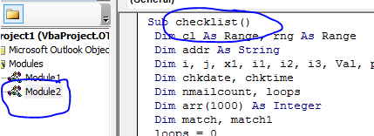

Step 3: In order to sync checklist label in mail first delete some codes and run the function

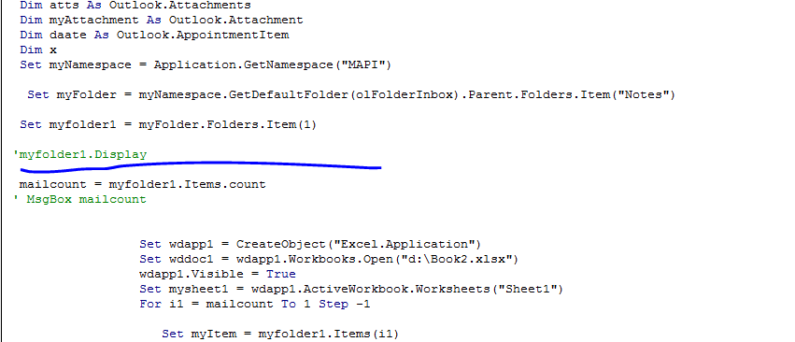

Delete code after blue line and uncomment myfolder1

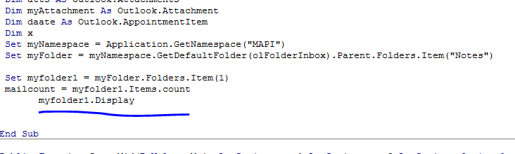

Step 4: run the code and the result looks like

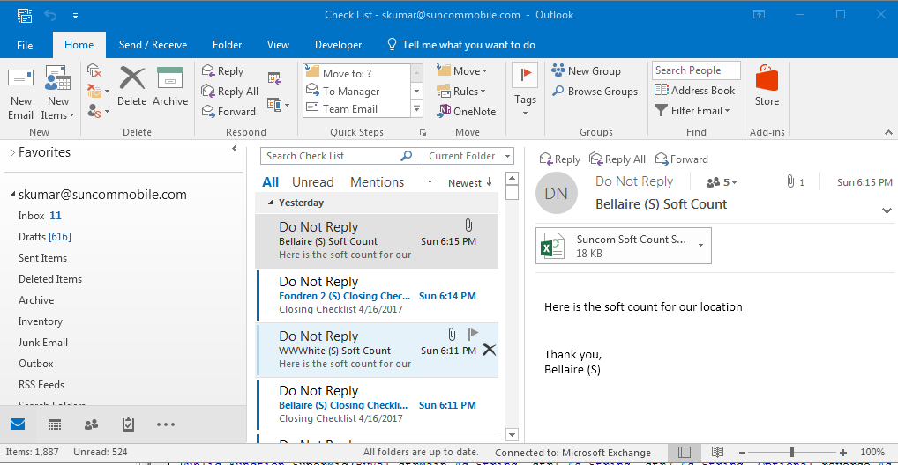

It shows check list label from skumar mail in that select Send and Receive and click Update folder

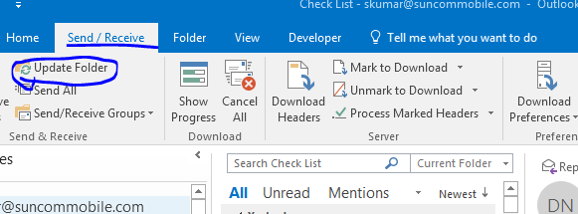

It takes a while to update the folder. After sync done close checklist and undo the VBA Editor to get older coding

Note : After cut the selected code don’t save the code undo the editor then save the code

Step 5: To push the mail content into excel create excel with 4 Sheets

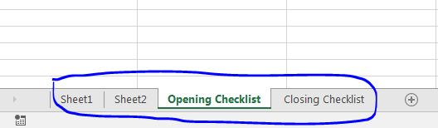

And name the sheets looks above

Step 6:Again launch outlook and launch VBA editor by alt+F11 then map the excel by location in coding

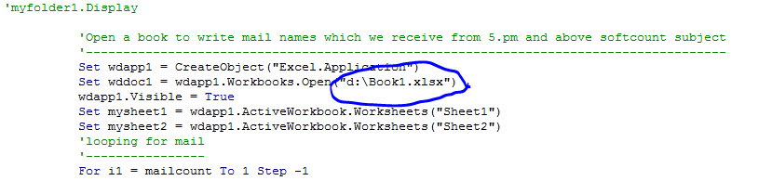then run the code wait for a while after execution the sheet has values looks like

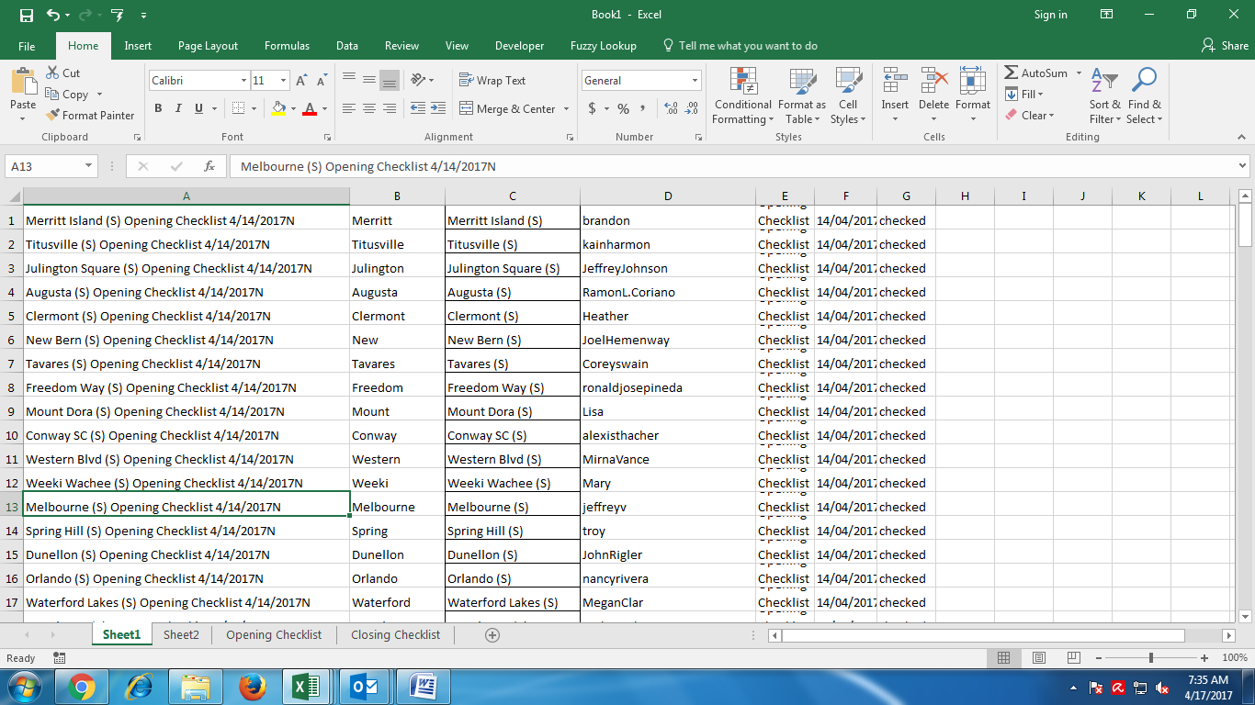

Sheet1 has opening checklist values and sheet2 has closing checklist values

Step 7: check opening checklist and closing checklist sheets has location names and checklist values

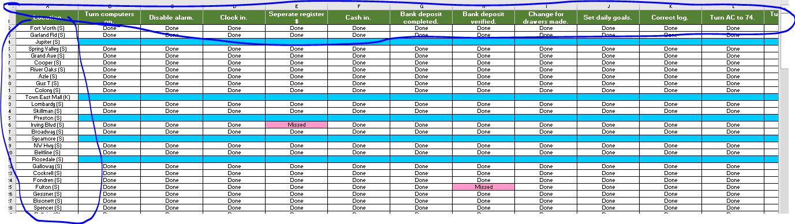

If the cells not available copy the value from older excel then lauch VBA editor in excel

Step 8: Again Check Excel VBA module and function looks like

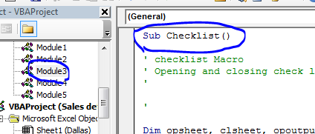

Step 9: Run the code and if any mismatch in date or sheet1 or 2 values not checked check the list manually

